InsectAI “Build a Camera Kit” Co-Design Workshop
Workshop Summary Report
Workshop held in Nis, Serbia, 23rd April 2026

Executive summary
This workshop explored how a low-cost insect camera “kit-for-kids” could support learning for children aged 8–12. Participants consistently framed the kit not as a simple identification tool, but as an interactive, experiment-driven educational system.
Key themes included:
- children as active investigators, not passive users
- strong interest in modular, reconfigurable systems
- emphasis on observing behaviour, ecology, and interactions
- enthusiasm for creative and immersive experiences
- AI understood as a supporting analytical tool, rather than a replacement for learning
These findings suggest that future development should prioritise open-ended exploration, modularity, and hands-on experimentation.

Overview
The workshop invited participants to design a low-cost insect camera “kit-for-kids”, aimed at children aged 8–12. The ambition was not only to introduce children to insects and biodiversity, but also to engage them with artificial intelligence, computer vision, and scientific investigation through hands-on activities.
Participants were asked to consider how such a kit could function in a classroom setting, what children might learn, and what kinds of interactions or experiments it could support. This report summarises the key ideas and themes emerging from the workshop and is intended to inform future design and prototyping.

Workshop format
The one-hour workshop began with a brief presentation introducing the project and its rationale, including insights from earlier discussions. Participants then worked in small groups for approximately 45 minutes, using two activity sheets to develop ideas. The session concluded with short group feedback.

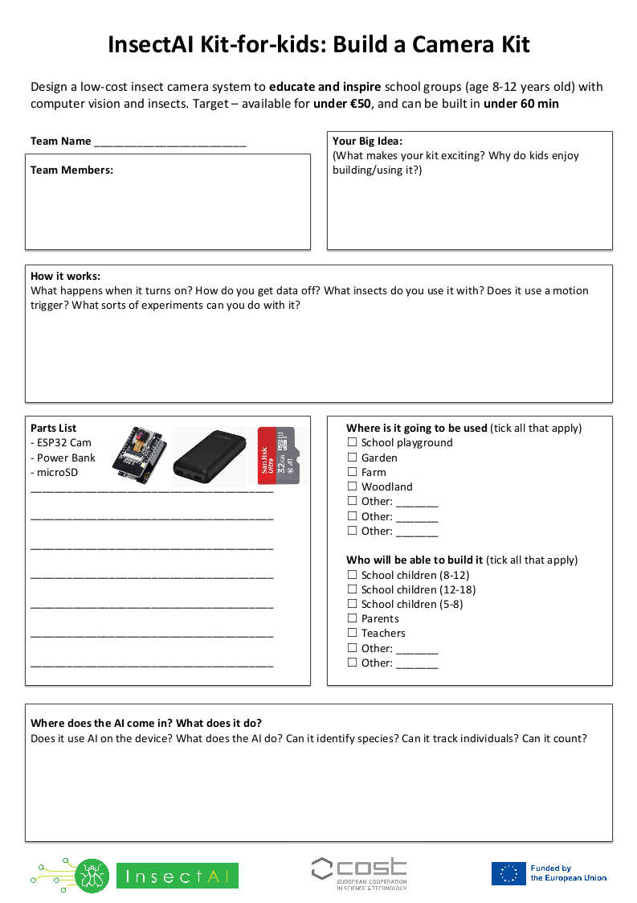
Activity sheets filled in by the participants of the workshop

Key findings

From tool to experience
Participants rarely imagined the system as simply a “camera for identifying insects.” Instead, they consistently framed it as an interactive educational experience combining ecology, experimentation, creativity, and technology.
Across groups, children were positioned as active participants; building, testing, observing, and interpreting, rather than passively receiving outputs from an automated system.
Implication: The design should prioritise engagement and agency, avoiding overly prescriptive or automated interactions.

Learning through experimentation
A dominant theme was the importance of experimentation. Many groups proposed systems that allowed children to manipulate environmental conditions and observe how insects responded:
- testing different food sources or attractants
- varying light or habitat conditions
- comparing behaviours across species
Some groups explicitly explored predator–prey interactions, food chains, and ecological relationships.
These ideas incorporated hypothesis testing, comparison, observation, and interpretation. Children were imagined as conducting small-scale ecological studies.
Implication: The kit should enable simple, repeatable experiments with visible outcomes, supporting hypothesis testing.

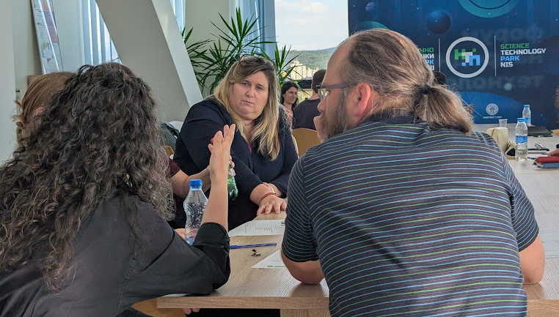
The ‘Be and insect’ group imagined using cameras to give children a “bug’s eye view”

Observing behaviour and movement
Some proposals focused on tracking insect movement and behaviour. A recurring concept involved maze-based systems, where insects move through structures while cameras record their behaviour.
Suggested features included:
- tracking movement paths
- comparing route choice
- analysing attraction to stimuli
- visualising behavioural patterns
Some groups proposed overhead cameras with graphical representations of movement, others emphasised physical interaction, with children redesigning mazes and environments.
Implication: Behaviour tracking is a compelling entry point for combining ecology, and AI.

Perspective-taking and empathy
One team imagined helping children “see the world like an insect.” Participants proposed placing cameras on toy insects to give children a “bug’s-eye view”. This idea was aimed at younger age groups and emphasised curiosity, imagination, and emotional engagement.
Implication: Incorporating perspective/empathy based elements could broaden engagement beyond purely analytical tasks.

Modularity and customisation
Participants consistently suggested modular and reconfigurable systems. Ideas included:
- interchangeable habitats or compartments
- attachable modules
- swappable attractants
- configurable environmental conditions
Some groups explicitly noted that kits should adapt to different age groups or lesson objectives.
This emphasis suggests that participants saw value in systems that evolve through use, supporting iteration, creativity, and long-term engagement.
Implication: Modularity should be a core design principle, enabling reuse across contexts rather than a single fixed activity.

Ecological relevance
Most proposals grounded the technology in real ecological questions, rather than abstract demonstrations. Examples included:
- ant navigation and collective behaviour
- choice experiments to understand food preference (including human food, sugar, scented water, etc)
- impact of habitat and climate on insect behaviour
Implication: Designs that link directly to real-world ecology are likely to be more meaningful and engaging.

Role of AI
AI was generally viewed positively, but as a supporting tool rather than a central feature. Proposed uses included:
- species identification
- counting insects
- tracking movement
- recognising patterns or behaviours
Importantly, some participants acknowledged limitations:
- classification may be uncertain
- similar species may be difficult to distinguish
- human interpretation remains essential
There was also discussion of on-device versus server-based processing, and concerns about data sharing (particularly images that might include children).
Implication: AI should be transparent, fallible, and clearly positioned as assisting, not replacing, the learning process.

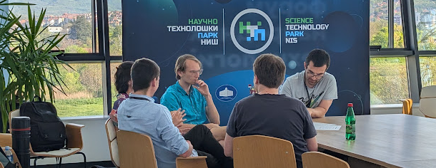
The ”Crash, Bang, Fight!” team imagined an arena where insects could interact with mazes, food and other insects

Hardware considerations
The workshop specified a baseline hardware configuration:
- ESP32 (camera and compute)
- power bank (power supply)
- SD card (data storage)
Within these constraints, participants proposed additional features such as:
- LEDs and macro lenses
- transparent and modular materials
- waterproofing and durability
- portability for classroom use
Implication: Practical considerations (robustness, usability, cost) are as important as functionality.

Design implications
Taken together, the findings suggest several priorities for development:
- Prioritise open-ended experimentation by making the kit modular and reconfigurable
- Focus on behaviour and interaction of insects, not just identification
- Emphasis AI as a support tool, but keep within its limitations, particularly given the low-cost compute to be used
- Incorporate creative and immersive elements
- Ground activities in real ecological questions

Conclusion and next steps
The workshop demonstrated a high level of creativity and engagement. Across diverse ideas, a consistent pattern emerged: participants were most excited by systems that allow children to discover for themselves.
Next steps
- Develop a small number of prototype concepts based on these themes
- Explore trade-offs between on-device and cloud-based AI
- Refine hardware design with cost, durability, and practicality in mind
- Test with target age groups (8–12)

